**Panetta and Partners law Firm**

We are a company that specializes in criminal defence law. The purpose of our site is to provide both current and prospective customers with information about our firm and the cases that we have successfully defended.

We want a site with a few simple pages that describe our firm, the lawyers working there, customer testimonials, etc. What is really important for us it to have the customer testimonials.

The color scheme is as follows:

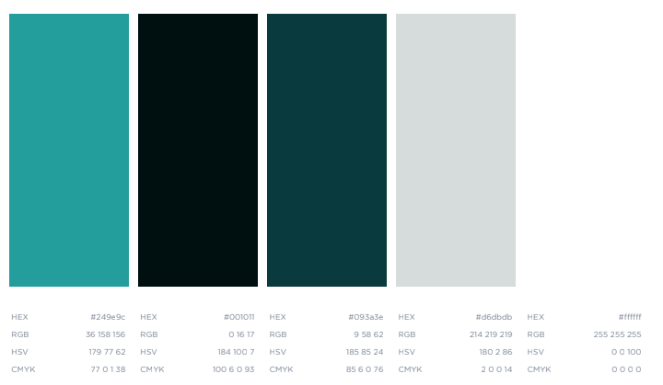

A sample website that we really liked:

<https://calgarydefence.com/>